

Acme Corporation

Digital Identity and Access Management

June 10, 2022

Table of Contents

Accenture Organization 3

Industry Experience 4

Our Businesses 5

Accenture History 6

Our Core Values 7

Accenture Organization

Accenture solves our clients' toughest challenges by providing unmatched services in strategy, consulting, digital, technology and operations. We partner with more than three-quarters of the Fortune Global 500, driving innovation to improve the way the world works and lives. With expertise across more than 40 industries and all business functions, we deliver transformational outcomes for a demanding new digital world.

Accenture’s Differentiators in the Marketplace to Deliver High Performance for Clients

* Long collaborative client relationships at the C-suite level with world’s leading companies
* Global breadth and depth across more than 13 industry groups and hundreds of offerings
* Powerful culture of innovation, collaboration and teaming
* Global Delivery Network that provides clients with high-quality solutions, lower costs and quicker results
* Functional specialists in particular industries and/or technological skills
* World’s largest independent technology services provider, experienced in complex, end-to-end transformational projects

Accenture is a global management consulting, technology services and outsourcing company, with approximately 401,000 people serving clients in more than 120 countries. As shown **Figure 1** Accenture collaborates with clients to help them become high-performance businesses and governments.

Figure 1. We bring unparalleled experience, comprehensive capabilities across all industries and business functions.

Our clients span the full range of industries. They include 94 of the Fortune Global 100 and more than 80 percent of the Fortune Global 500. For example, all of our top 100 clients have been clients for at least five years, and 98 have been clients for at least 10 years.

Of Accenture’s 401,000 employees, more than 6,600 are managing directors. We have offices and operations in more than more than 200 cities in 55 countries. We operate globally with one, common methodology and business model: this enables us to serve our clients seamlessly.

# Industry Experience

Accenture delivers services and solutions through focused industry groups within operating groups, as **Figure 2** shows. This industry focus provides Accenture professionals with a thorough understanding of industry evolution, business issues and applicable technologies, enabling Accenture to deliver solutions tailored to each client's industry.

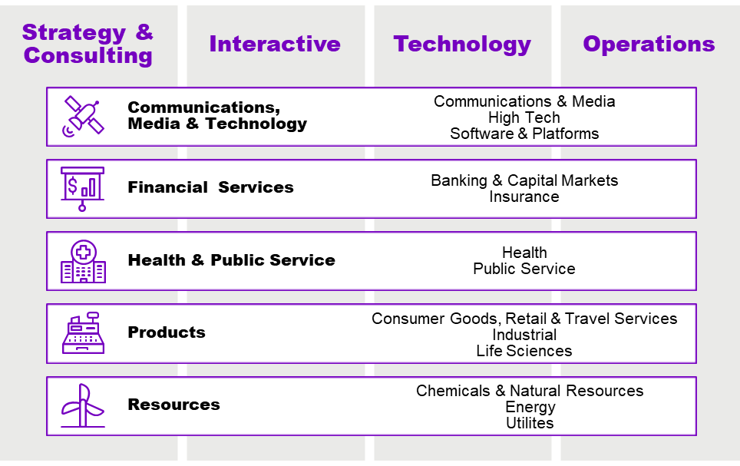

Figure 2. Accenture provides a wide range of services to private and public sector clients across all major industry groups.

**Accenture Development Partnerships**

Accenture Development Partnerships works collaboratively across government, business and civil society, and at the intersection of international development and digital technologies.

We bring innovative thinking and approaches from the private sector to help development organizations deliver sustainable outcomes to drive effectiveness today and prepare for tomorrow. By tapping into the best of Accenture's ecosystem and alliance partners—global reach, extensive capabilities, cross-industry perspectives and a skilled workforce—we can provide end-to-end solutions to help address complex social issues.

**Accenture Innovation Architecture**

In today's business environment, companies need to continually reinvent themselves. At Accenture, we take an innovation-led approach to help clients "imagine and invent" their future. Through the Accenture Innovation Architecture, we combine our capabilities to invent, develop, and deliver disruptive innovations for clients, and to scale them faster.

# Our Businesses

A world of talent, one team

Across 200 cities and 19 industries, we work as one team with a common goal—to create 360° value by embracing change.

**Strategy & Consulting**

**Envision and execute change at speed and scale.**

**Interactive**

**Design, build, communicate and run meaningful experiences at the intersection of purpose and innovation.**

**Technology**

**Accelerate change across your enterprise to create lasting value.**

**Operations**

**Create intelligent new ways to harness change and grow.**

Our businesses – Strategy & Consulting, Interactive, Technology and Operations - are the innovation engines through which we build world-class skills and capabilities; develop our knowledge capital; and create, acquire and manage key assets central to the development of solutions for our clients.

These businesses allow us to offer clients the broad, deep skills necessary for a diverse range of services. Service lines of specialization define each business further. By aligning our staff in this manner, we can make our skills available to each operating and industry group.

Each line of business provides unique insight to our clients, and we often assemble cross-business teams to support complex transformations.

# Accenture History

Continuous innovation and rapid transformation have been themes throughout Accenture's history, which the company traces to the 1950s with the installation of the first computer system for commercial use in the United States at General Electric’s Appliance Park facility by the company then named Arthur Andersen.



Across the globe, one thing is universally true of the people of Accenture:

We care deeply about what we do and the impact we have with our clients and communities. It is personal to all of us.

— Julie Sweet, Chief Executive Officer

The company built its reputation primarily as a technology consultant and systems integrator. In 1989, Andersen Consulting began offering a new breed of business integration solutions to clients—solutions that aligned organizations' technologies, processes and people with their strategies—and established as a separate, independent business unit, devoted solely to management and technology services and solutions.

We changed our name to “Accenture” in January 2001 with a new brand and image in the marketplace. We listed on the New York Stock Exchange with the symbol “ACN” in June 2001.

Throughout its history, Accenture has expanded its offerings and capitalized on evolving management trends and technologies to benefit its clients. The company pioneered systems integration and business integration; led the deployment of enterprise resource planning, customer relationship management and electronic services; and has established itself as a leader in today's global marketplace.

# Our Core Values

Of all our accomplishments, we take pride in our business performance, diversity and corporate citizenship. We're honored to be recognized for our successes.

Accenture’s Core Values have shaped the culture and defined the character of our company, guiding how we behave and make decisions:

|  |  |
| --- | --- |
| Characteristics |  |
| Stewardship | Fulfilling our obligation of building a better, stronger and more durable company for future generations, protecting the Accenture brand, meeting our commitments to stakeholders, acting with an owner mentality, developing our people and helping improve communities and the global environment |
| Best People | Attracting, developing and retaining the best talent for our business, challenging our people, demonstrating a “can-do” attitude and fostering a collaborative and mutually supportive environment |
| Client Value Creation | Enabling clients to become high-performance businesses and creating long-term relationships by being responsive and relevant and by consistently delivering value |
| One Global Network | Leveraging the power of global insight, relationships, collaboration and learning to deliver exceptional service to clients wherever they do business |
| Respect for the Individual | Valuing diversity and unique contributions, fostering a trusting, open and inclusive environment and treating each person in a manner that reflects Accenture’s values |
| Integrity | Being ethically unyielding and honest and inspiring trust by saying what we mean, matching our behaviors to our words and taking responsibility for our actions |